Spalding County Kiwanis Fair – Canning Exhibits

Friday, September 20 – Saturday, September 28, 2024
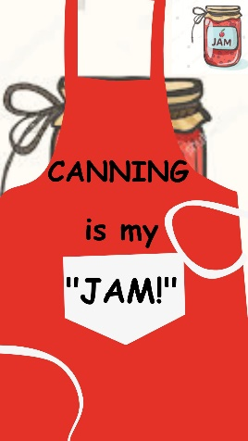

All entries must be entered at the Kiwanis Fairgrounds

Drop off: Friday, September 13, 2024, 12 p.m.– 4 p.m. & Saturday, September 14, 2024, 10 a.m. – 11 a.m.
Pick up: Sunday, September 29, 2024, 2:30 p.m. – 3:30 p.m.

For questions, call 770-467-4225 Spalding County Extension

All entries must follow the USDA/National Center for Home Food Preservation canning guidelines.

This is an ADULT ONLY competition. Exhibitors must be 19 years of age or older.

- All entries must have been preserved within the last year (12months). Only items canned since September 30, 2024, are eligible for entry. Old canning will be disqualified.

- All entries MUST have labels on the entry with the canner’s name, class, and lot number. Entries without required labeling will not be judged.

- Unsealed exhibits or products showing signs of spoilage will not be judged.

- Clean, standard (quarts, pints, half-pints, or quarter-pints) canning jars with new standard lids and rings (rust free) left on must be used. NO other jars will be accepted or judged.

- All entries must be sealed to be entered. Entry should be clean - sides of jar, under band and on top of lid.

- NO more than ONE entry may be made in one LOT by any one individual.

- Premiums will be 1st place - $8.00 2nd place - $5 3rd place - $3
Grand Champion $15

updated 8/8/2024

2023 Canning Divisions

Class  Lot | 1 – Fruit  - Apple  - Blackberry  - Blueberry |  | - Chow-Chow  - Bread & Butter  - Okra  - Green Tomato
 | 4. Fig |  | 11. Kraut
 | 5. Peach |  | 12. Other pickles
 | 6. Pear
 | 7. Fruit Salsa | Class | 5 – Jellies
 | 8. Baby Food | Lot | 1. Apple
 | 9. Other Fruit |  | 2. Blackberry
 |  |  | 3. Grape
Class | 2 – Vegetables |  | 4. Peach
Lot | 1. Beans (green) |  | 5. Plum
 | 2. Lima Beans, Peas |  | 6. Pepper
 | 3. Corn |  | 7 Scuppernong/Muscadine
 | 4. Pumpkin |  | 8. Strawberry
 | 5. Tomatoes |  | 9. Other Jellies
 | 6. Soup Mix
 | 7. Salsa | Class | 6 – Marmalades & Jams
 | 8 Other Vegetables | Lot | 1. Blueberry Jam
 |  |  | 2. Blackberry Jam
Class | 3 – Preserves & Butters |  | 3. Fig Jam
Lot | 1. Berry |  | 4. Muscadine/Scuppernong
 | 2. Fig |  | 5. Peach Jam
 | 3. Peach |  | 6. Plum Jam
 | 4. Pear |  | 7. Strawberry Jam
 | 5. Strawberry |  | 8. Other Fruit Jam
 | 6. Other Preserves |  | 9. Marmalades
 | 7. Apple Butter
 |  | Class | 7 – Miscellaneous &
Class | 4 – Pickles |  | Sauces
Lot | 1. Cucumber – sweet | Lot | 1. Pepper Sauce
 | 2. Cucumber – dill |  | 2. Tomato Sauce
 | 3. Peach – Pear |  | 3. Other Sauces
 | 4. Fruit Relish or Chutney |  | 4. Juices
 | 5. Pepper |  | 5. Pie Filling
 | 6. Vegetable Relish or |  | 6. Other Miscellaneous
Chutney

